GET HOOKED at LAKE GRACE.
with Robin Inkpen.

A creative way to use up your fabric stash

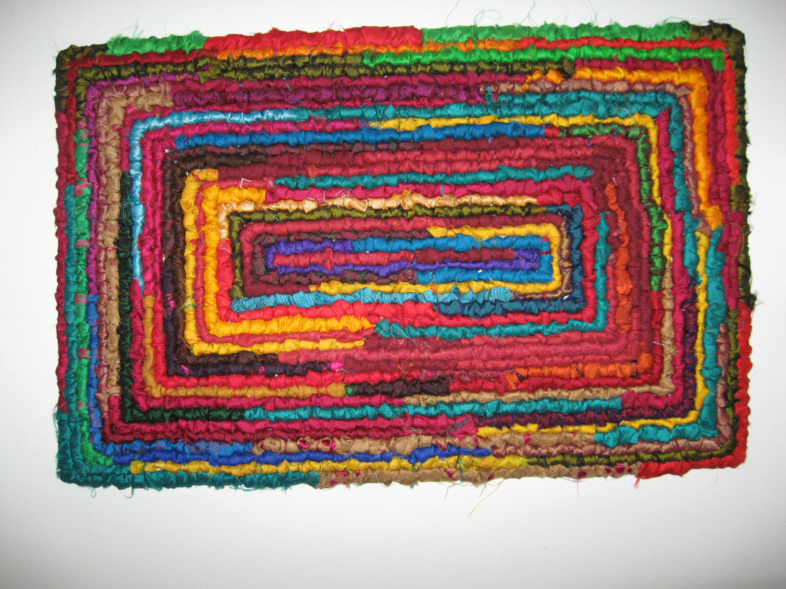

At Lake Grace Regional Artspace
25 Stubbs St, Lake Grace.
March 20th
9.30am - 4pm

Locker Hooking is one of the many methods of making rag rugs. Today artisans are using it for many different projects - baskets, tablemats, bags, bracelets, lamps and of course rugs.

This workshop will be an introduction to Locker Hooking.
Each participant will receive a placemat kit containing the rug backing cut to a table mat size, a locker hook tool, a large needle, instruction and information sheets and there will be ample amounts of fabric and yarn supplied to make the table mat. All will be provided. There is nothing for the participant to bring to the workshop except your lunch.
The value of the kit is $20 and included .
Early Bird (available from Feb 22 - Mar 2) $80.
Full Price (available from Mar 2 - Mar 13) $90.

BOOKING IS THROUGH EVENTBRITE

