Plants and Sacred Geometry Workshop
by Pauline Melrose White.

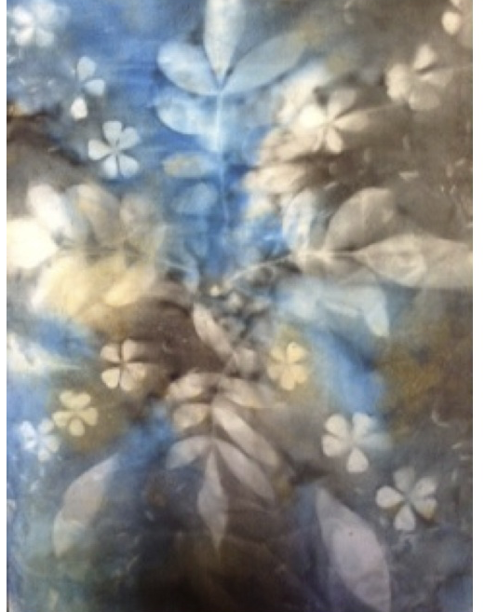
Pauline has been researching the morphic field of plants. They recently have taken her to Hawaii where she learnt of the language of plants and in this workshop she
will share her research with you.

By unifying aspects of her findings into joyful and fun process you will get amazing results as the elements of life - water, sun and plants plus our intention and some dye-all move and morph into patterns of unbelievable beauty. It is a magical process and very informative and personal to the maker.

You will need one T-shirt (natural fibre) plus another piece of fabric or garment of natural fibre (eg cotton, silk, bamboo, linen) and experience this process for yourself.
A full materials list of requirements will be available on application.
Pauline is an Arts practitioner of 25 years, Lecturer, Curator, Writer and Public Arts Co-Ordinator.

ArtGeo Gallery,
4-7 Queen Street,
Busselton.
Saturday April 30th.
9.30 - 4pm.
Early Bird (available Apr 1-11) $80
Full Price (available Apr 12 - 23) $90.
A Materials fee of $20 applies.
Please bring your own lunch.

Booking is through Eventbrite.

