Reconstructing Fashion Workshop
by Lorelie Smit.

Have fun taking existing clothing and creatively deconstructing and combining items resulting in unique garments.

In this workshop you will learn how to reconstruct clothing from your wardrobe and transform your op-shop treasures. All that is needed is basic sewing skills, a sewing machine in good working order and a sense of fun!

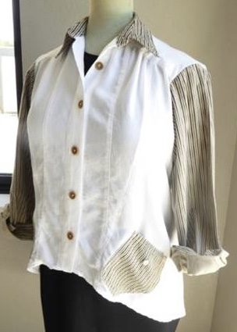

ArtGeo Gallery
4-7 Queen St,
Busselton.

Sunday April 17th
9.30am-4pm
Early Bird (available Mar 19 - 30) $80
Full Price (available Mar 30 - Apr 9) $90.
Please bring your own lunch.

Booking is through EVENTBRITE

