Fabulous Ferrous Workshop,
with Kerrie Argent.

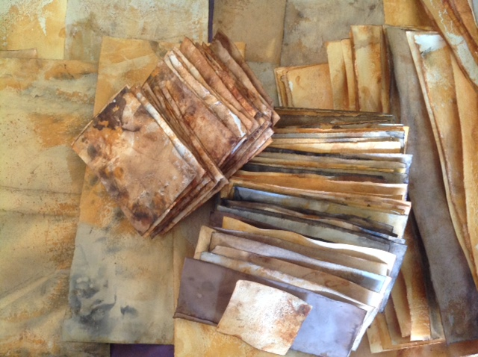

Rusting paper is fun, exciting and you are only limited by your imagination. What you create depends on the amount of rust you use or the heat and humidity of your location, the minerals in your water and the type and weight of your paper.
This is very much a come and play experimental spontaneous process. Be surprised and excited about all the beautiful colours and marks that uncontrollably evolve from the rusting process.
ArtGeo Gallery,
4-7 Queen Street,
Busselton.
Sunday, April 10th.
9.30 - 4pm.

Early Bird Price: (available from Mar 13 - 23) $80
Full Price (from Mar 24 - April 3) $90
A Materials fee of $20 applies.

Please bring your own lunch.

Booking is through Eventbrite

