GET KNOTTED .....
with Rowan Rovere.

Using 6 basic knots construct a wall hanging,
potplant holder, jewellery or whatever takes
your fancy.

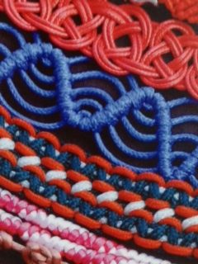

Use natural or recycled materials or a combination
of both and see what amazing things can emerge from
a few knots.
Beginners and advanced welcome.

ArtGeo Gallery
4-7 Queen St
Busselton.

Sunday May 1st
9.30am-4pm
Early Bird (available Apri 1 - 10) $80
Full Price (available Apr 11 - 23) $90
Materials fee of $20 is applicable
Bring own lunch.

Booking is through Eventbrite.

