Making Felt in the Third Dimension..

The creation of felt is a playful and magical experience.
Come and play with Martien van Zuilen.

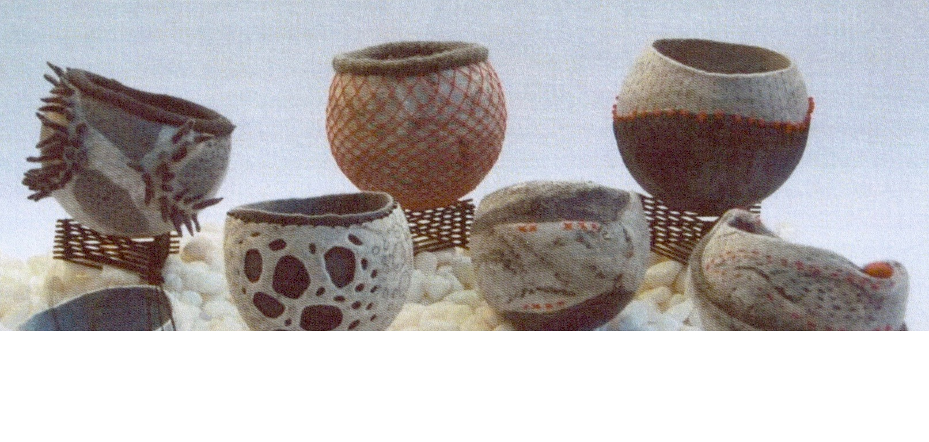
This hands-on class explores the sculptural qualities of felt; through the making of a felt vessel you will learn valuable techniques to create your own 3D felt styled to your own interest.
The focus will be on working with resist, colour and fibre blending, textural effects and the varied effects of incorporating elementary stitch. This class will give you a sound set of skills to play to your heart's content and gain inspiration for more advanced projects. Even without felting experience you will enjoy and learn from this class.
A full Requirements List is available after registration.
More information on the artist www.martienvanzuilen.com.

ArtGeo Gallery,
4-7 Queen Street,
Busselton.

Saturday April 16th,
9.30 - 4pm.
Early Bird (available Mar 18 - 29) $80.
Full Price (available Mar 30 - Apr 9) $90.
A Materials fee of $15 for items Martien will supply.
Please bring your own lunch.

Booking is through Eventbrite

Wafta Logo.

